**Project Planning Phase**

**Project Planning Template (Product Backlog, Sprint Planning, Stories, Story points)**

|  |  |
| --- | --- |
| Date | 18 October 2022 |
| Team ID | PNT2022TMID05431 |
| Project Name | Efficient Water Quality Analysis & Prediction using Machine Learning |
| Maximum Marks | 8 Marks |

**Product Backlog, Sprint Schedule, and Estimation (4 Marks)**

Use the below template to create product backlog and sprint schedule

|  |  |  |  |  |  |  |
| --- | --- | --- | --- | --- | --- | --- |
| **Sprint** | **Functional**  **Requirement (Epic)** | **User Story**  **Number** | **User Story / Task** | **Story Points** | **Priority** | **Team**  **Members** |
| Sprint-1 | Data Collection | USN-1 | Collecting dataset for pre-processing | 2 | High | Dharshini K |
| Sprint-1 |  | USN-2 | Data pre-processing used to transform the data into useful format. | 1 | High | Divya Dharshini P |
| Sprint-2 | Model Building | USN-3 | Calculate the Water Quality Index (WQI) using Regression algorithm of machine learning | 2 | Low | Harishma K |
| Sprint-2 |  | USN-4 | Splitting the data into training and testing from the entire dataset. | 2 | Medium | Hesini Priya R |
| Sprint-3 | Application Building | USN-5 | Implementing the web page for collecting the data from user | 1 | High | Dharshini K |
| Sprint-4 | Training and Testing | USN-6 | Training the model using regression algorithm and testing the performance of the model | 2 | High | Divya Dharshini P |
| Sprint-4 |  | USN-7 | Deploying the model using IBM Cloud and IBM Watson Studio | 2 | Medium | Harishma K |

**Project Tracker, Velocity & Burndown Chart: (4 Marks)**

|  |  |  |  |  |  |  |
| --- | --- | --- | --- | --- | --- | --- |
| **Sprint** | **Total Story Points** | **Duration** | **Sprint Start Date** | **Sprint End Date (Planned)** | **Story Points**  **Completed (as on**  **Planned End Date)** | **Sprint Release Date (Actual)** |
| Sprint-1 | 20 | 6 Days | 24 Oct 2022 | 29 Oct 2022 | 20 | 29 Oct 2022 |
| Sprint-2 | 20 | 6 Days | 31 Oct 2022 | 05 Nov 2022 | 20 | 05 Nov 2022 |
| Sprint-3 | 20 | 6 Days | 07 Nov 2022 | 12 Nov 2022 | 20 | 12 Nov 2022 |
| Sprint-4 | 20 | 6 Days | 14 Nov 2022 | 19 Nov 2022 | 20 | 19 Nov 2022 |

**Velocity:**

Imagine we have a 10-day sprint duration, and the velocity of the team is 20 (points per sprint). Let’s calculate the team’s average velocity (AV) per iteration unit (story points per day)

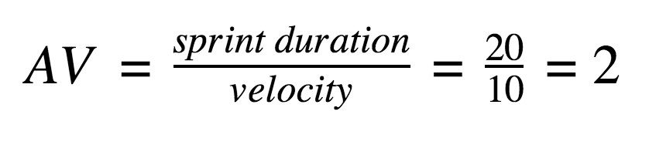

Sprint 1: Average Velocity = 20/2 = 10

Sprint 2: Average Velocity = 20/2 = 10

Sprint 3: Average Velocity = 20/1 = 20

Sprint 4: Average Velocity = 20/2 = 10

**Burndown Chart:**

A burn down chart is a graphical representation of work left to do versus time. It is often used in agile [software development](https://www.visual-paradigm.com/scrum/what-is-agile-software-development/) methodologies such as [Scrum.](https://www.visual-paradigm.com/scrum/scrum-in-3-minutes/) However, burn down charts can be applied to any project containing measurable progress over time.

